**1** SELECT * FROM TrendsInStartups_Explorin;

SELECT count(name) FROM TrendsInStartups_Explorin ;

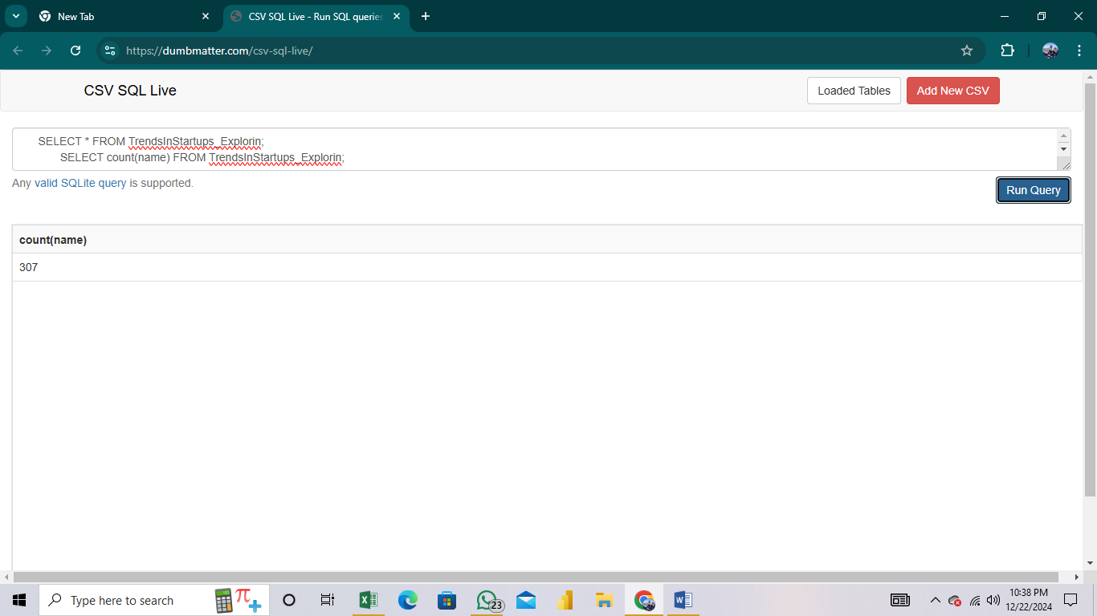

**2** select * from TrendsInStartups_Explorin;

select sum(valuation) from TrendsInStartups_Explorin

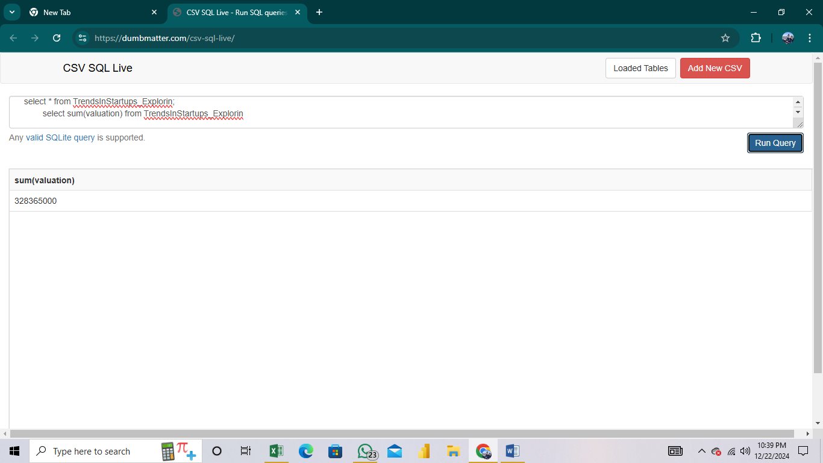

**3** SELECT * FROM TrendsInStartups_Explorin;

select max(amount_raised) , stage from TrendsInStartups_Explorin;

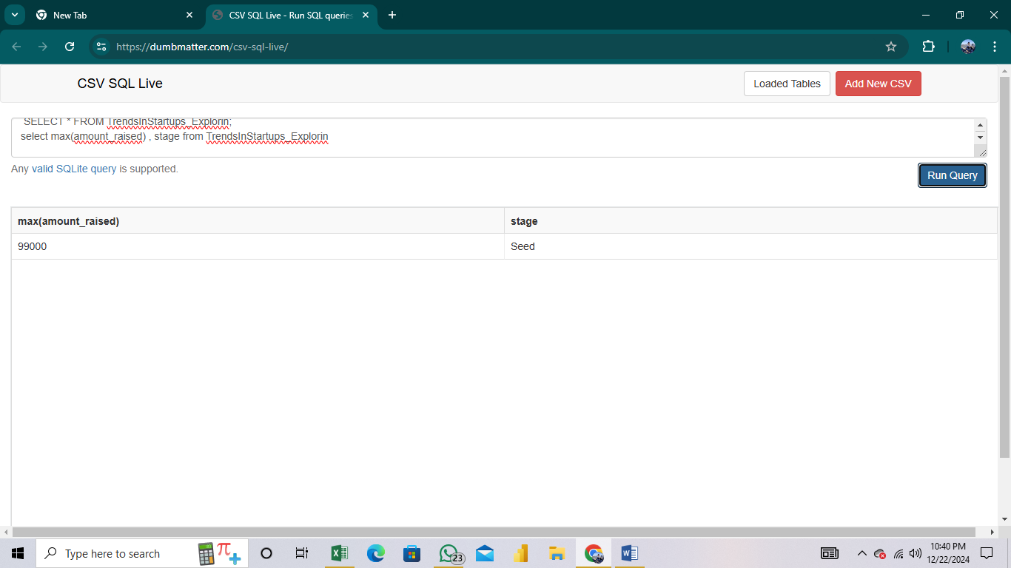

**4** select * from TrendsInStartups_Explorin;

select min(founded_year) from TrendsInStartups_Explorin;

select name, founded_year from TrendsInStartups_Explorin

where founded_year = "2002"

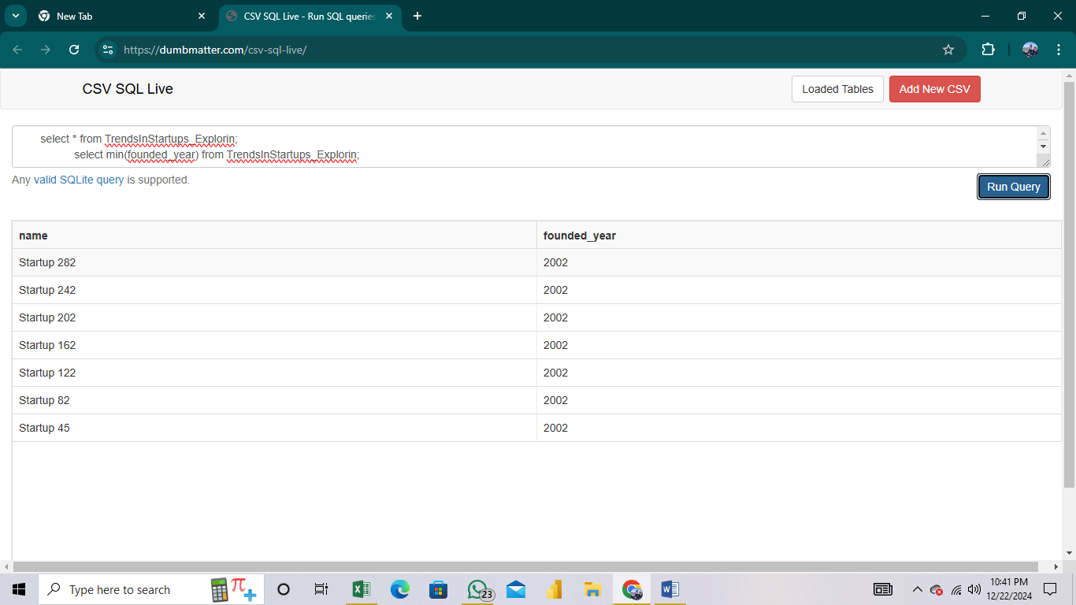

**5** select * from TrendsInStartups_Explorin;

select sector, avg(valuation) from TrendsInStartups_Explorin

group by sector;

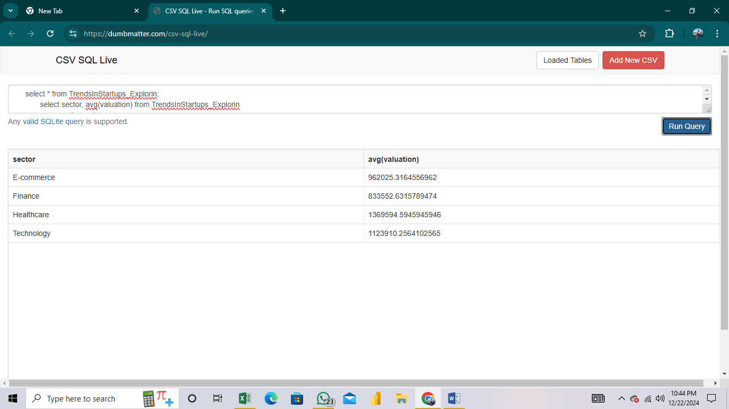

**6** select * from TrendsInStartups_Explorin;

select count(name), location from TrendsInStartups_Explorin

group by location limit 1;

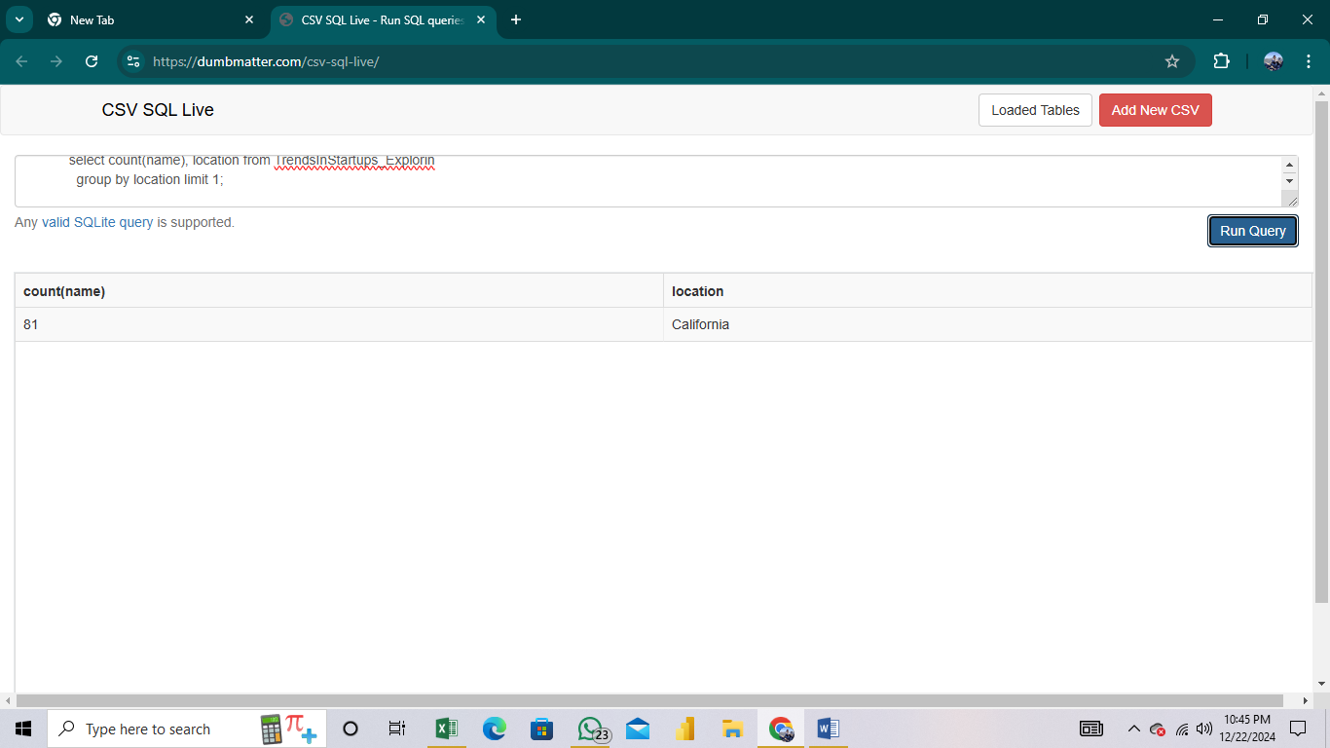

**7** select * from TrendsInStartups_Explorin;

select avg(size), location from TrendsInStartups_Explorin

where size > 500

group by location;

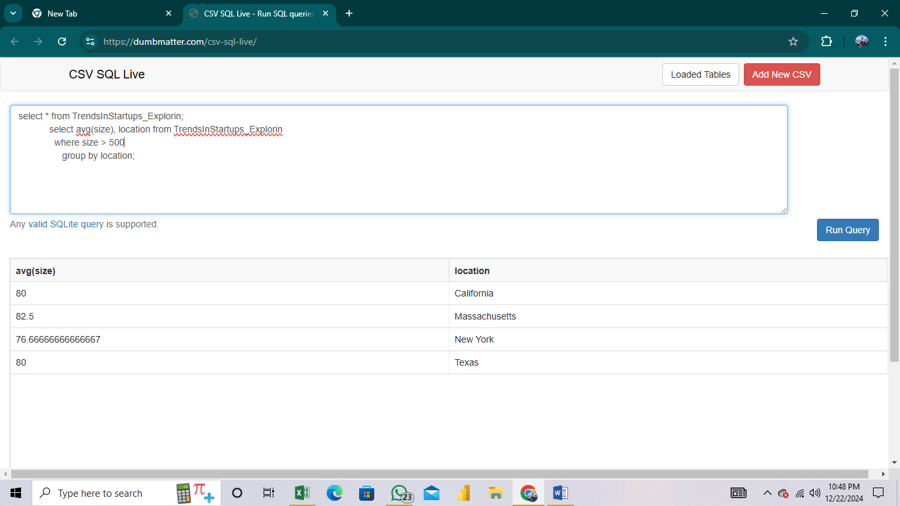

8 SELECT * FROM TrendsInStartups_Explorin;

select count(id) from TrendsInStartups_Explorin;

SELECT * FROM TrendsInStartups_Explorin;

select valuation from TrendsInStartups_Explorin

order by valuation desc limit 15;

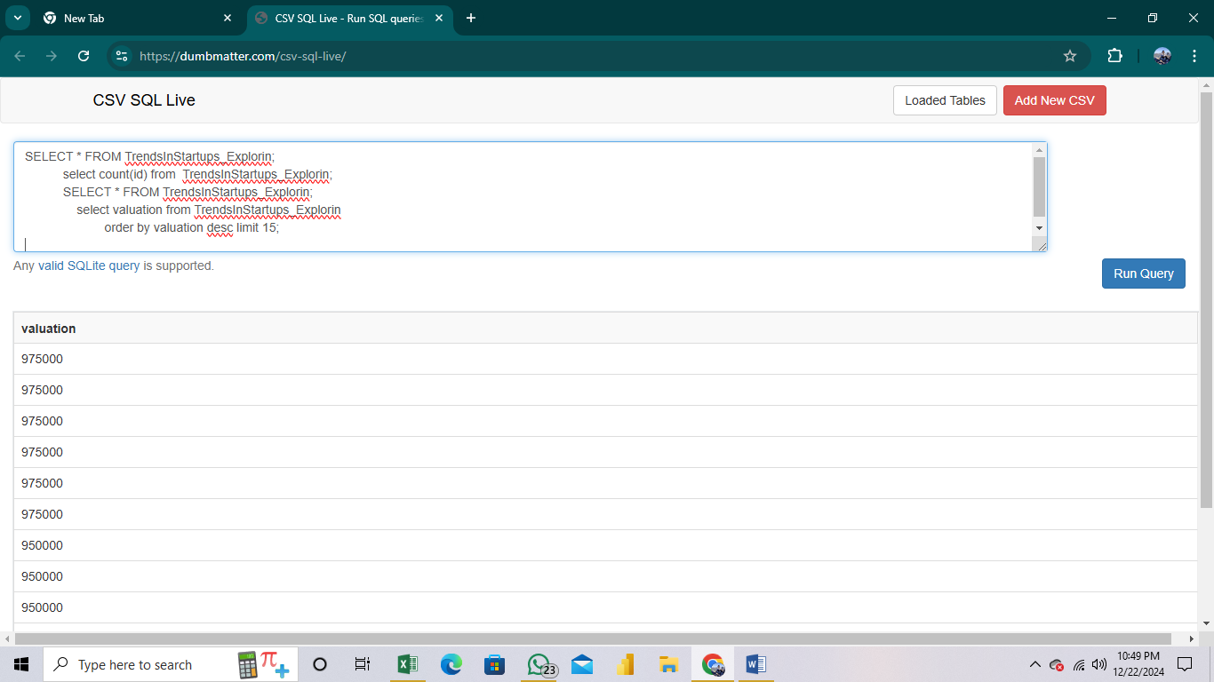

9 SELECT name

FROM TrendsInStartups_Explorin

GROUP BY name

HAVING COUNT(DISTINCT stage) = (SELECT COUNT(DISTINCT stage) FROM TrendsInStartups_Explorin)

**10**

**SELECT s.name, ROUND(((a.valuation - s.valuation) / s.valuation) * 100, 2) AS percentage_growth FROM**

**(SELECT name, valuation FROM TrendsInStartups_Explorin WHERE stage = 'Seed') s JOIN**

**(SELECT name, valuation FROM TrendsInStartups_Explorin WHERE stage = 'Series A') a**

**ON s.name= a.name ORDER BY**

**percentage_growth DESC**